Part 1:

Assignment Description
Write a recursive function which takes a parameter of a nonnegative integer and generates a pattern of stars as shown below.
Also, write a program that prompts the user to enter the number of lines in the pattern and uses the recursive function to generate the pattern. Use at least three different test cases.

1 Readme Documentation
This program creates a pattern of stars using a recursive function and allows the user to choose the length of the pattern.

2 Flowchart Screen Shots
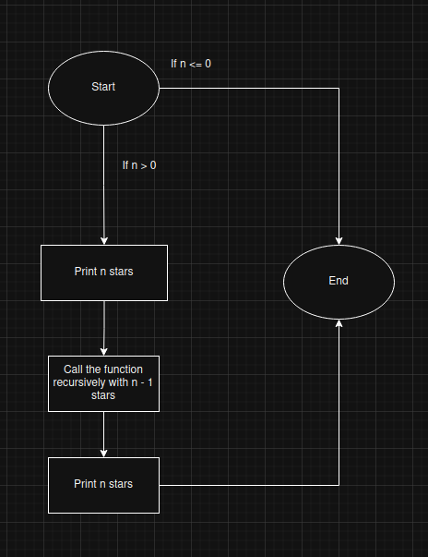

3 UML and Use Case Diagrams

4 Source Code of All files (.h, .cpp)
#include <iostream>
#include <string>

/*
*Name: Recursive Pattern
*Author: Wesley Hixon
*Date Last Updated: 11/25/2025
*Purpose: Generates a pattern using a recursive function
*/

void recursivePattern(int stars);
int getIntInput(int low, int high, std::string prompt);

int main(){
bool running = true;
while(running){
int input;

input = getIntInput(0, 25, "How many lines would you like in your star pattern? Max 25. Enter 0 to exit: ");
if(input == 0) break;

std::cout << std::endl;
recursivePattern(input);
std::cout << std::endl;
}
return 0;
}

int getIntInput(int low, int high, std::string prompt){
int input;
std::cout << prompt << std::endl;

bool valid = false;
while(!valid){
std::cin >> input;
if(!std::cin){
std::cin.clear();
std::cin.ignore(100000, '\n');
std::cout << "Please try again." << std::endl << prompt;
continue;
}
else if(input > high || input < low){
std::cout << "Please try again." << std::endl << prompt;
continue;
}
valid = true;
}

return input;
}

void recursivePattern(int stars){
if(stars <= 0) return;

std::cout << std::string(stars, '*') << std::endl;
recursivePattern(stars - 1);
std::cout << std::string(stars, '*') << std::endl;
}

5 Three Use Case Screen Shots
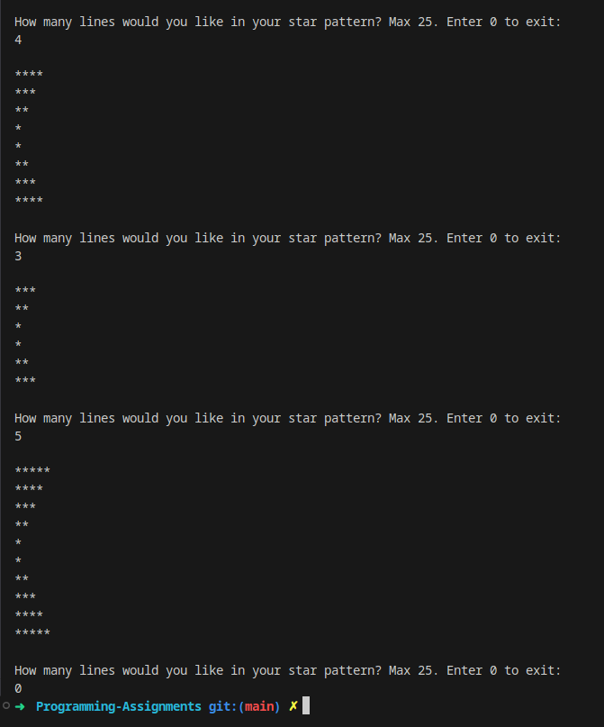

Part 2:

Assignment Description
Write a recursive function to implement the recursive algorithm of Excercise 16 in the new book. (reverse the the elements of an array between two indices). Also write a program to test your function.

1 Readme Documentation
This program reverses a range of ints in a vector using a recursive function. The vector is 10 integers long and the user is allowed to choose the range to be reversed.

2 Flowchart Screen Shots
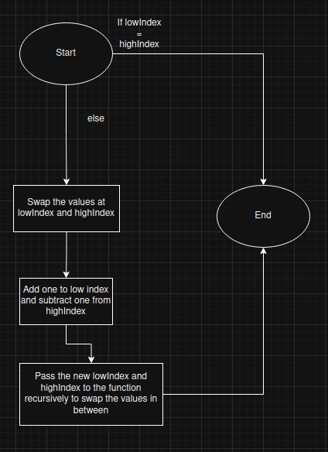

3 UML and Use Case Diagrams

4 Source Code of All files (.h, .cpp)
#include <iostream>
#include <vector>

/*
*Name: Recursive Array Reversal
*Author: Wesley Hixon
*Date Last Updated: 11/25/2025
*Purpose: Reverses the order of a range of ints in a vector using a recursive function
*/

void reverseArray(int lowIndex, int highIndex, std::vector<int> &arr);
int getIntInput(int low, int high, std::string prompt);

int main(){
std::vector<int> arr = {1, 2, 3, 4, 5, 6, 7, 8, 9, 10};

std::cout << "Original Array: ";
for(int element : arr){
std::cout << element << ' ';
}
std::cout << std::endl;

int highIndex = getIntInput(1, arr.size() - 1, "Please enter the high index of the range you would like to reverse: ");
int lowIndex = getIntInput(0, highIndex, "Please enter the low index of the range you would like to reverse: ");

reverseArray(lowIndex, highIndex, arr);

std::cout << "Reversed Array: ";
for(int element : arr){
std::cout << element << ' ';
}

std::cout << std::endl;
return 0;
}

int getIntInput(int low, int high, std::string prompt){
int input;
std::cout << prompt << std::endl;

bool valid = false;
while(!valid){
std::cin >> input;
if(!std::cin){
std::cin.clear();
std::cin.ignore(100000, '\n');
std::cout << "Please try again." << std::endl << prompt;
continue;
}
else if(input > high || input < low){
std::cout << "Please try again." << std::endl << prompt;
continue;
}
valid = true;
}

return input;
}

void reverseArray(int lowIndex, int highIndex, std::vector<int> &arr){
if(lowIndex >= highIndex || highIndex > arr.size() || lowIndex < 0){
return;
}

std::swap(arr[lowIndex], arr[highIndex]);
lowIndex++;
highIndex--;
reverseArray(lowIndex, highIndex, arr);
}

5 Three Use Case Screen Shots
